Images of the Moon

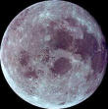 www.alumni.caltech.edu/ ~yukimoon/

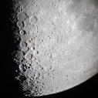 www.astrosurf.com/ cidadao/moon_obs.html

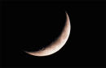 www.dmasonline.org/.../ hailey-moon-crescent.jpg

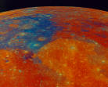 nssdc.gsfc.nasa.gov/ imgcat/hires/gal_p41477.gif

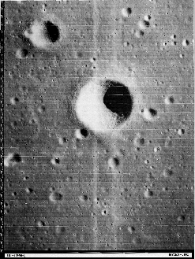

nssdc.gsfc.nasa.gov/ imgcat/hires/lo3_h194_1.gif

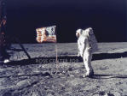 www.amnh.org/rose/ backgrounds/moon.jpg

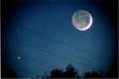 www.utahskies.org/.../ moon/moon_and_planets.html

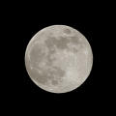 www.wanhalablog.com/ archives/week_2002_05_26.htm

